**Name: Sarah Thomas**

**Reg. No. 23BSA10160**

**Slot: A11 + A12 + A13**

**Subject: AWS Cloud Practitioner**

**Date: 01/08/2025**

***Experiment 5***

***Snapshot with EBS***

1. Create and Launch EC2 instance.

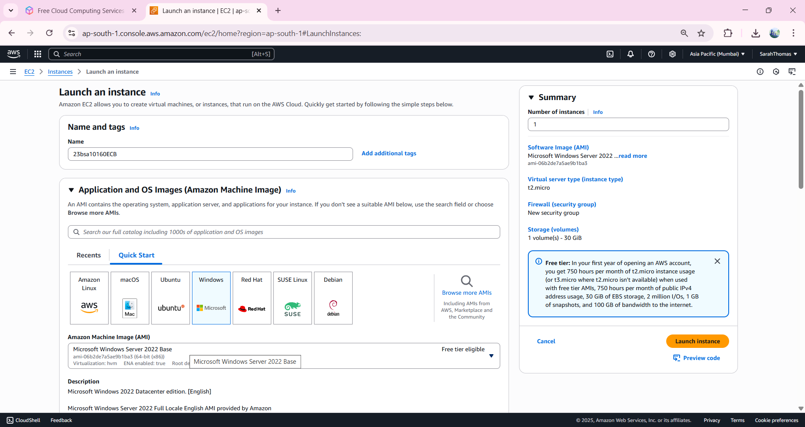  
  
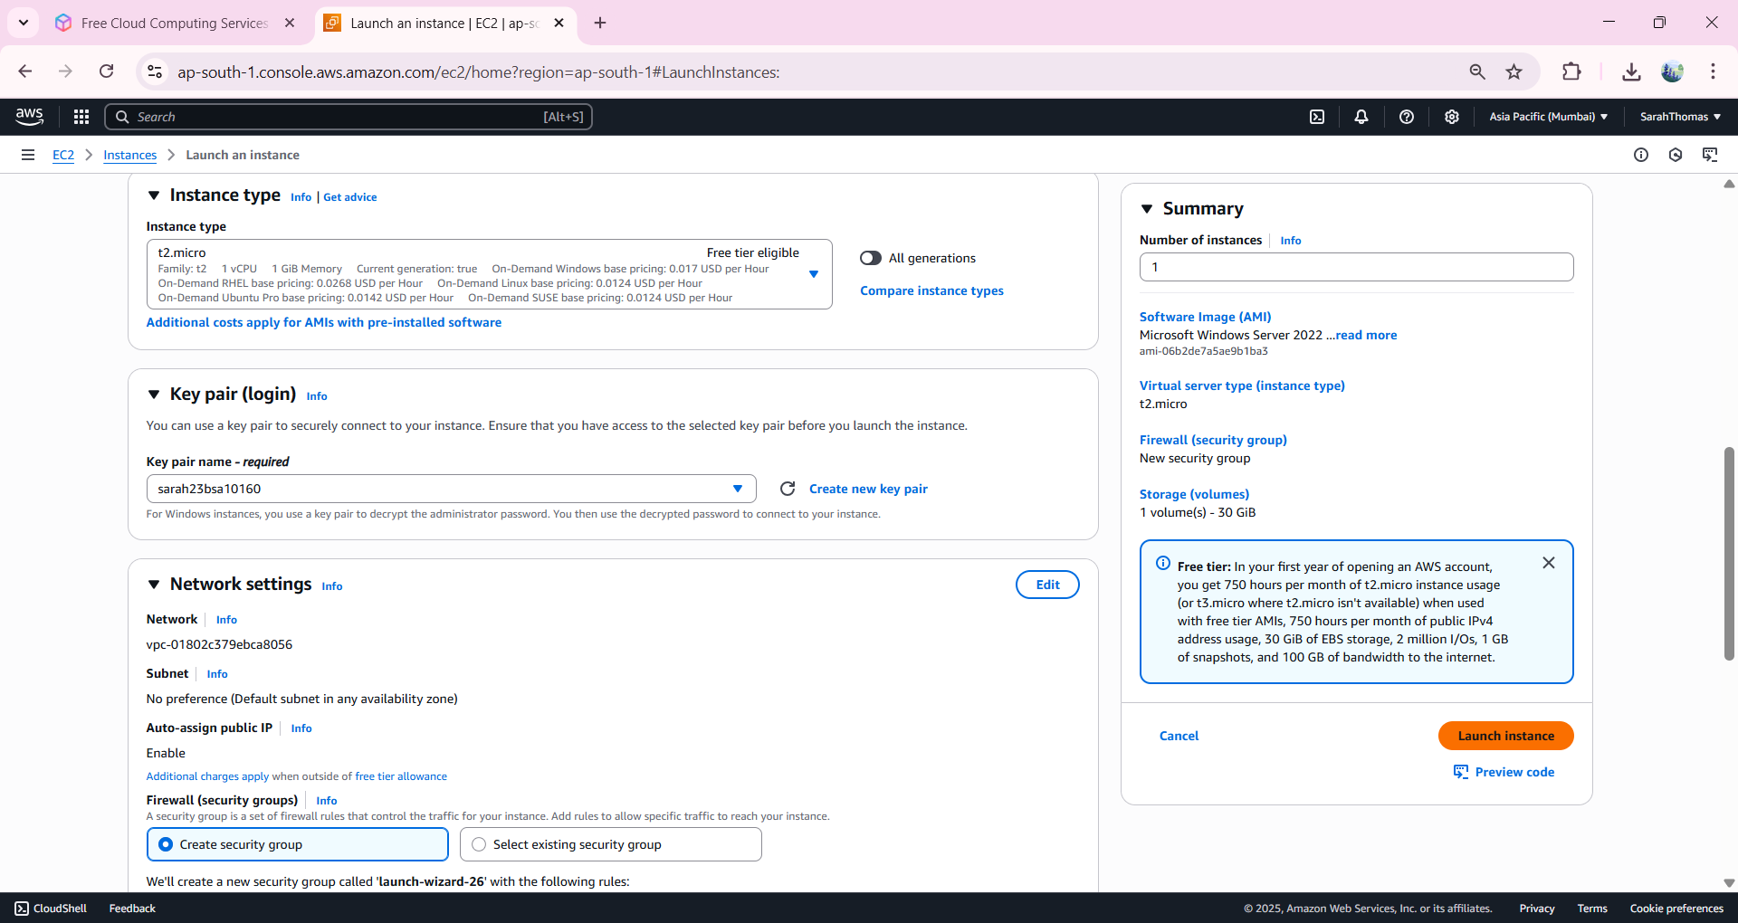

1. Navigate to Elastic Block Storage -> Volumes.  
   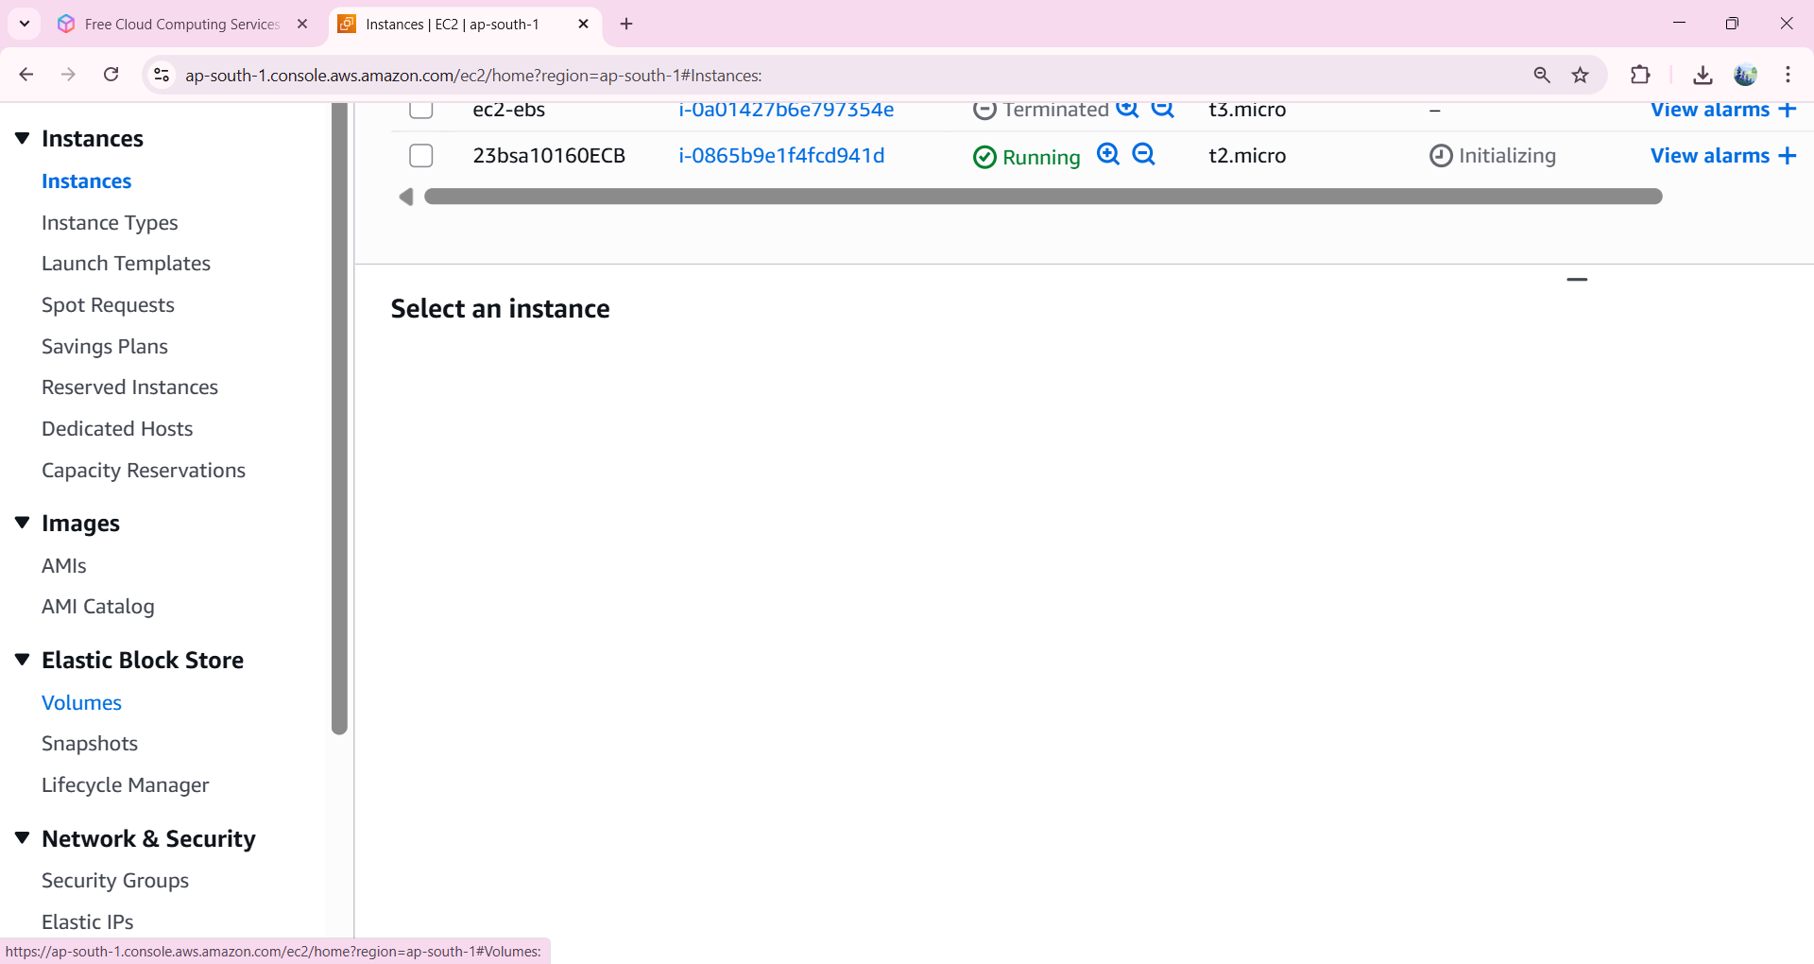
2. Rename the created Volume as Vol1.  
   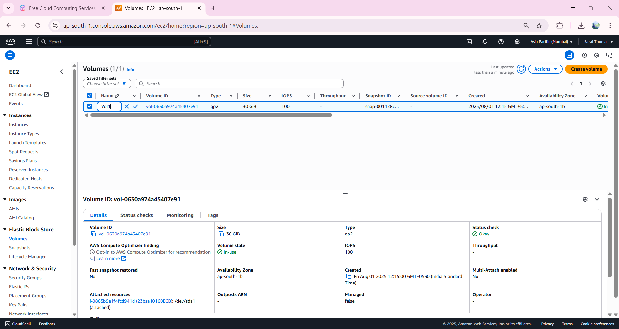
3. Select the Volume and click on Actions -> Create snapshot.  
   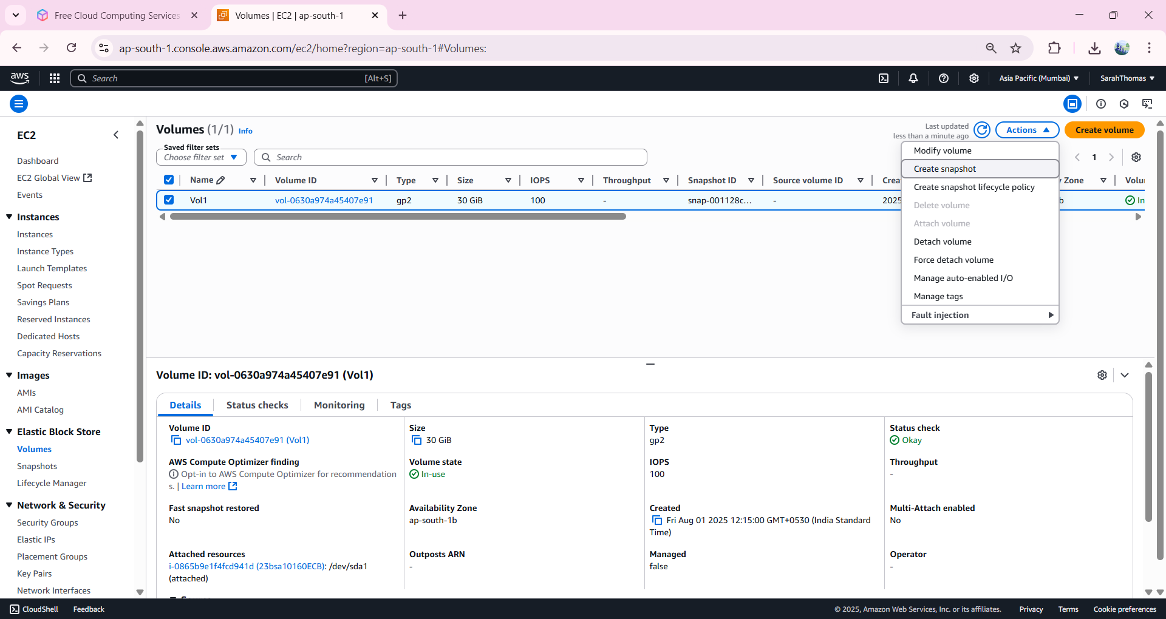
4. Give appropriate description and Click on Create Snapshot.  
   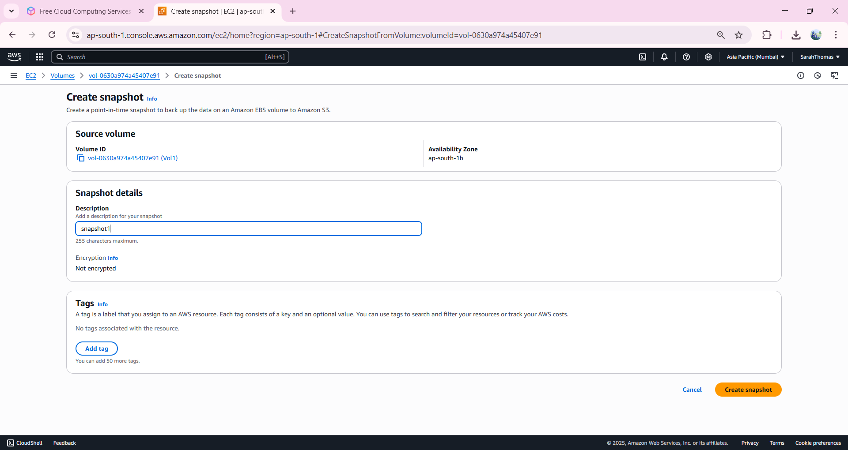
5. Navigate to Snapshots -> Rename as snap1.  
   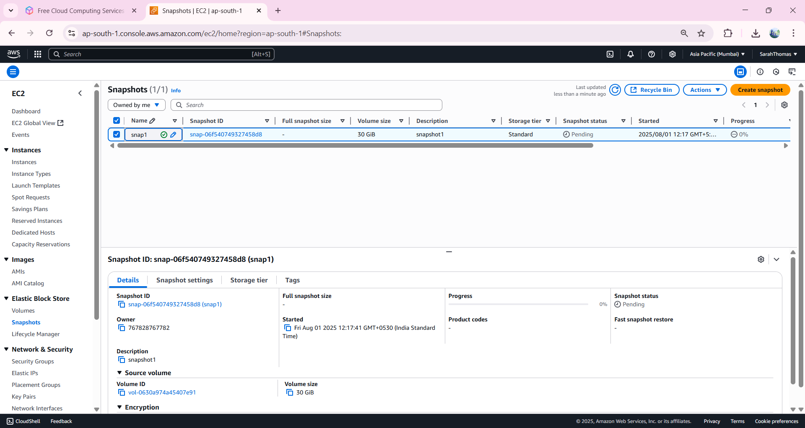
6. Once the status is ‘*COMPLETED’*, select the snapshot -> Actions -> Create volume from snapshot.  
   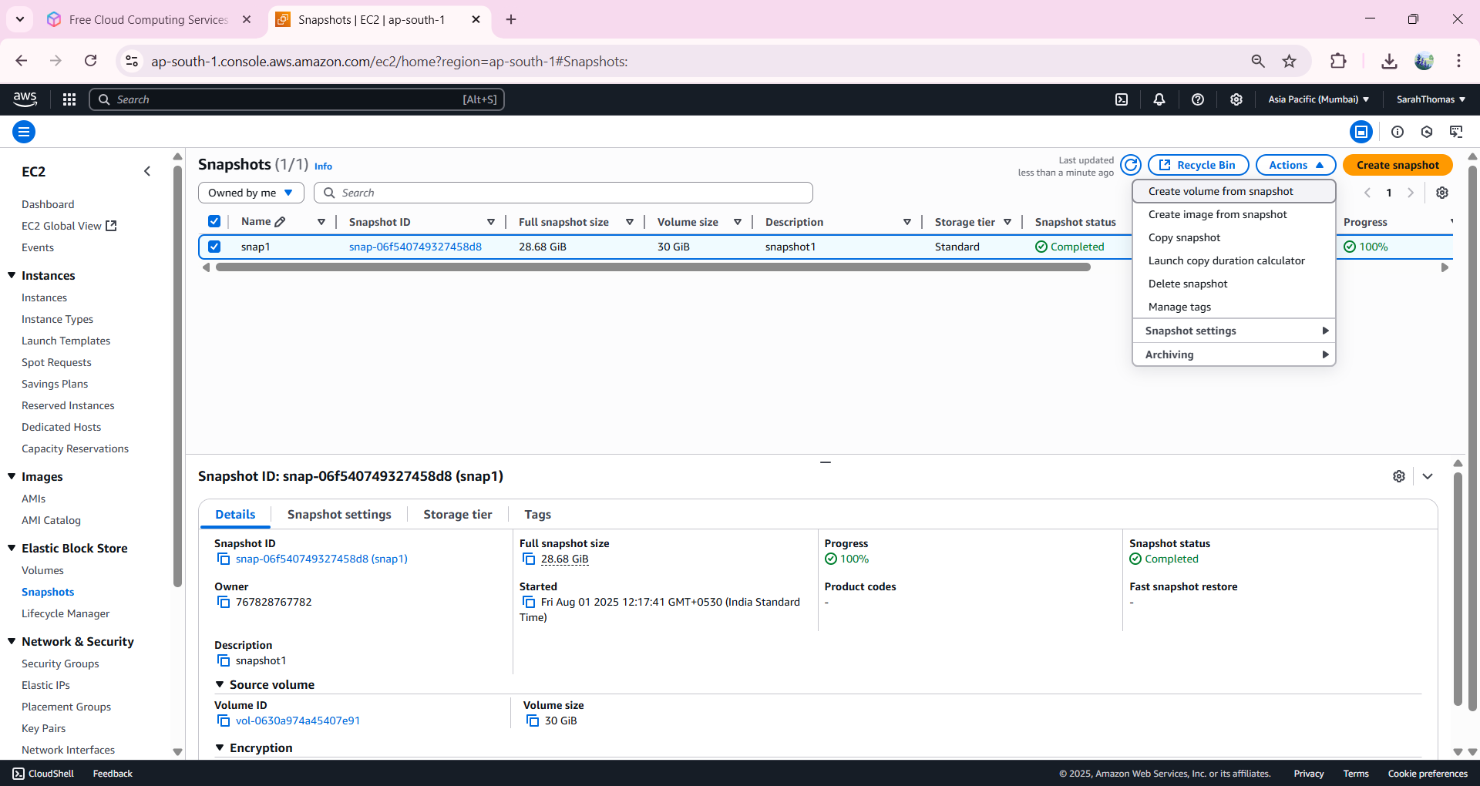
7. Make sure that the volume to be created has to be in the same AZ as that of the EC2 instance.  
   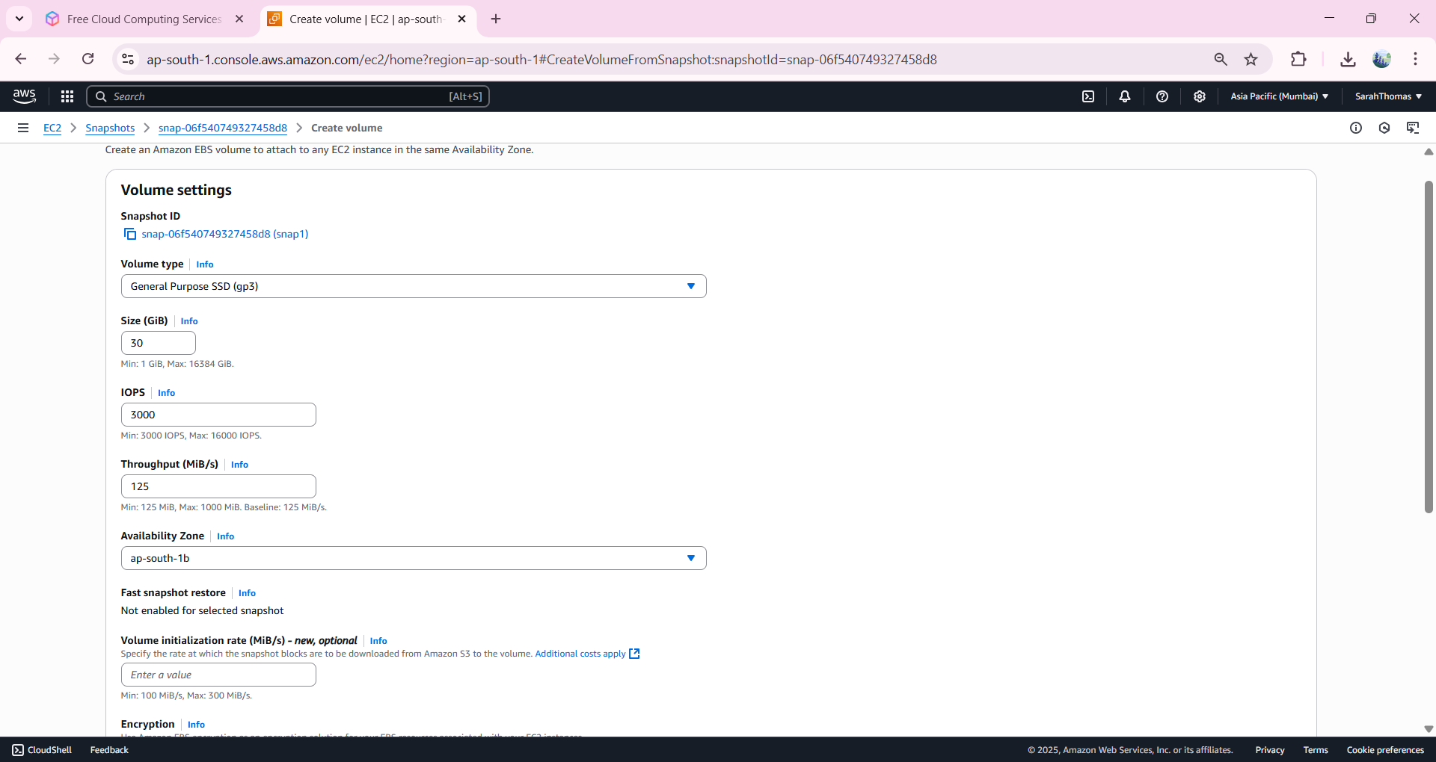
8. Then click on create Volume.  
   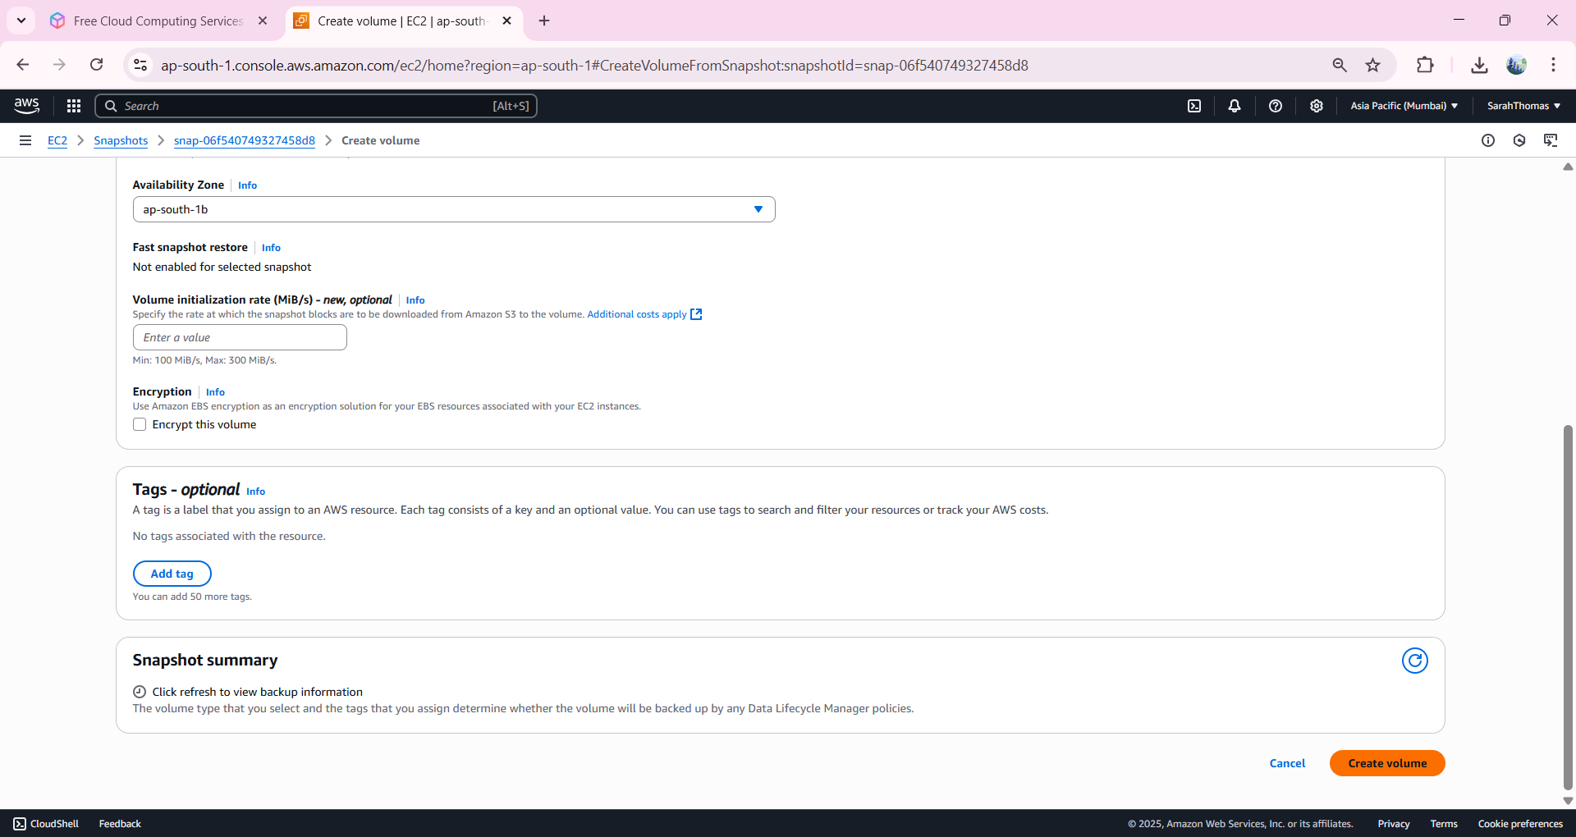
9. Navigate to Volumes and rename the created volume as vol2.  
   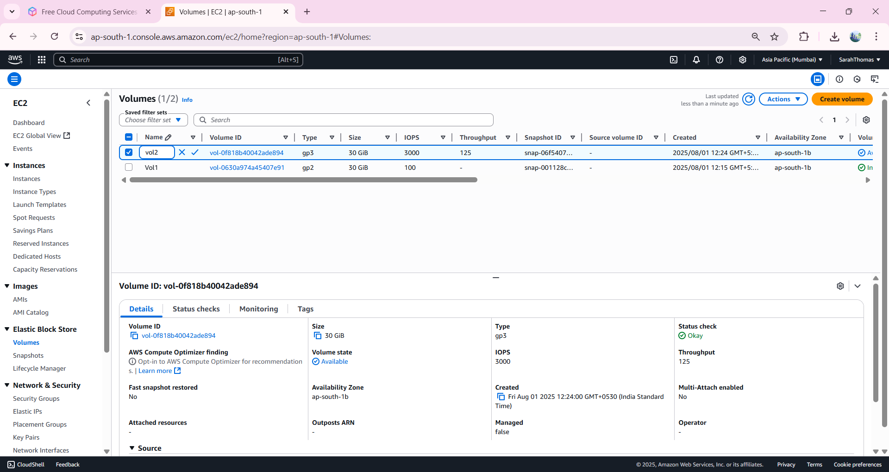
10. After creating the vol2,   
    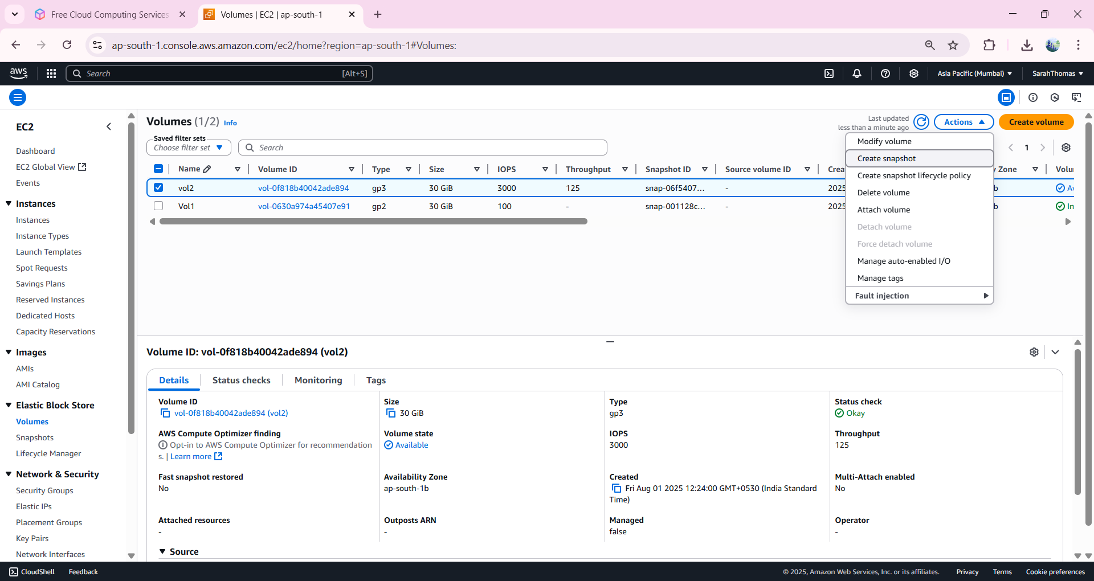
11. Give description of snapshot and click on create snapshot.  
    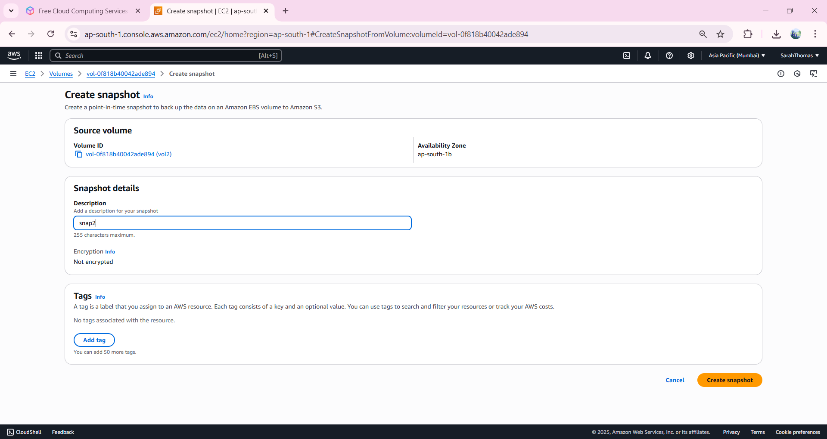
12. Navigate to Snapshot -> rename as snap2.  
    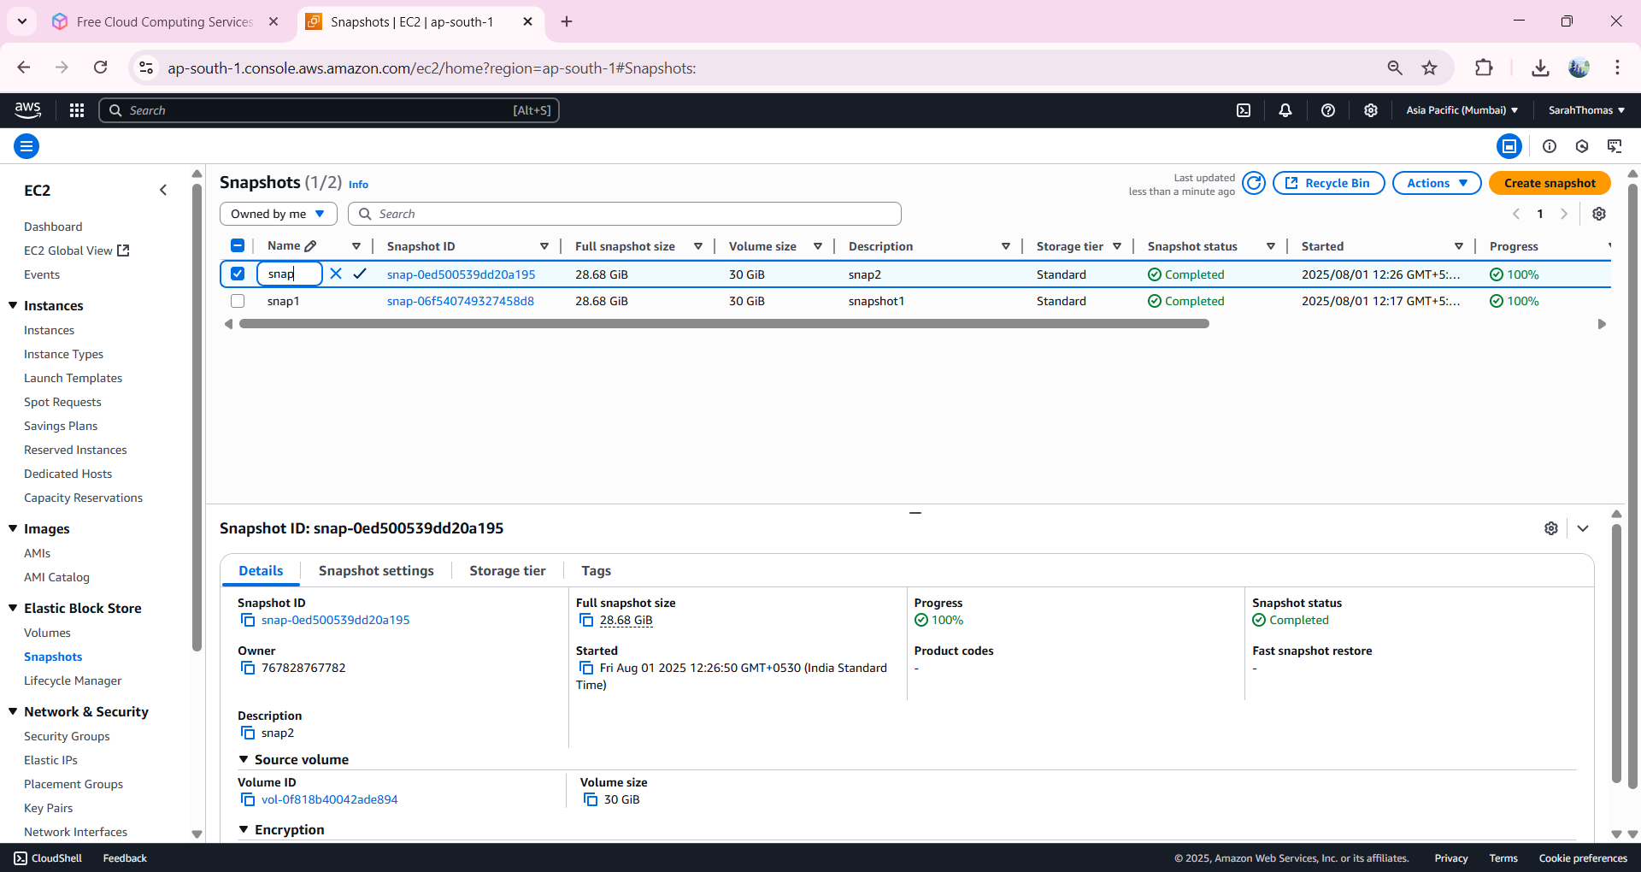
13. Click to vol2 -> Actions -> Attach Volume.  
    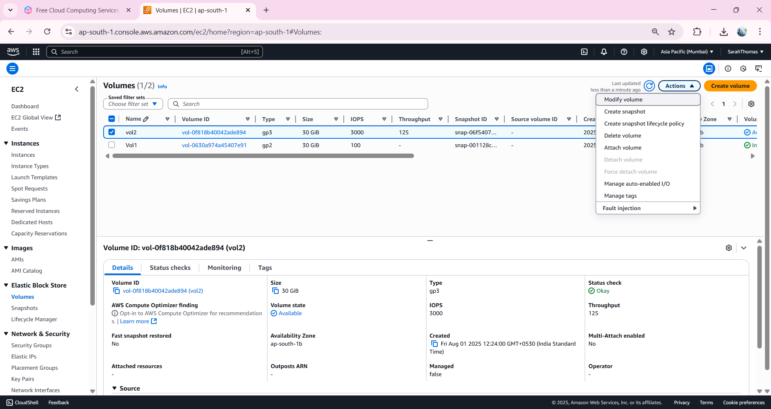
14. Add the created EC2 and give device name.  
    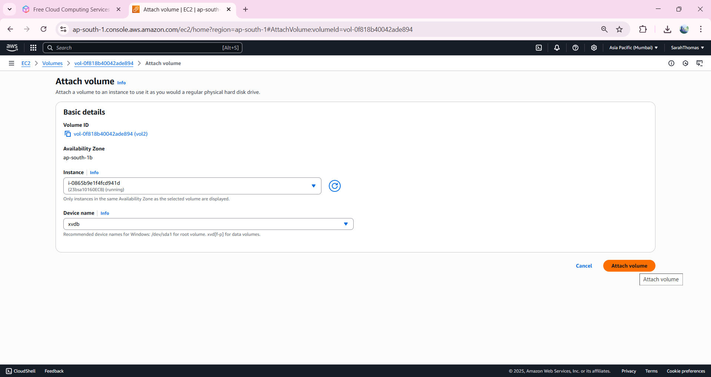
15. Now when we navigate to created instance -. Storage.  
    We observe that a single EC2 is connected to two EBS.  
      
    